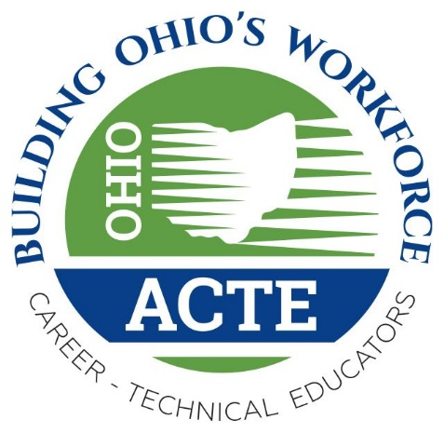

Tentative Agenda
2017 Ohio ACTE Fall Leadership and Empowerment Meeting
Sept. 1, 2017
Great Lakes Science Center
601 Erieside Ave,
Cleveland, OH 44114

Leadership and Innovation

Registration: 9:00 am
9:00 am - Coffee, conversation
9:45 am – Welcome and Introductions – Nate Bishko, Ohio ACTE President
10:00 am – Noon* – Perspectives on Leadership, Business and Education
11:45 – 12:30 – Lunch (included)
12:30 – 1:00 pm – ODE Update
1:00 pm – MC2 STEM High School/Tour the Science Center
2:30 pm – Adjourn/Wrap Up
** Break Time to be determined

